Examples of Portfolio Evidence
Log-Book
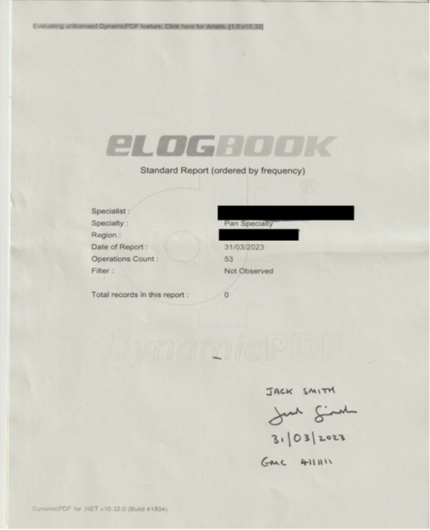

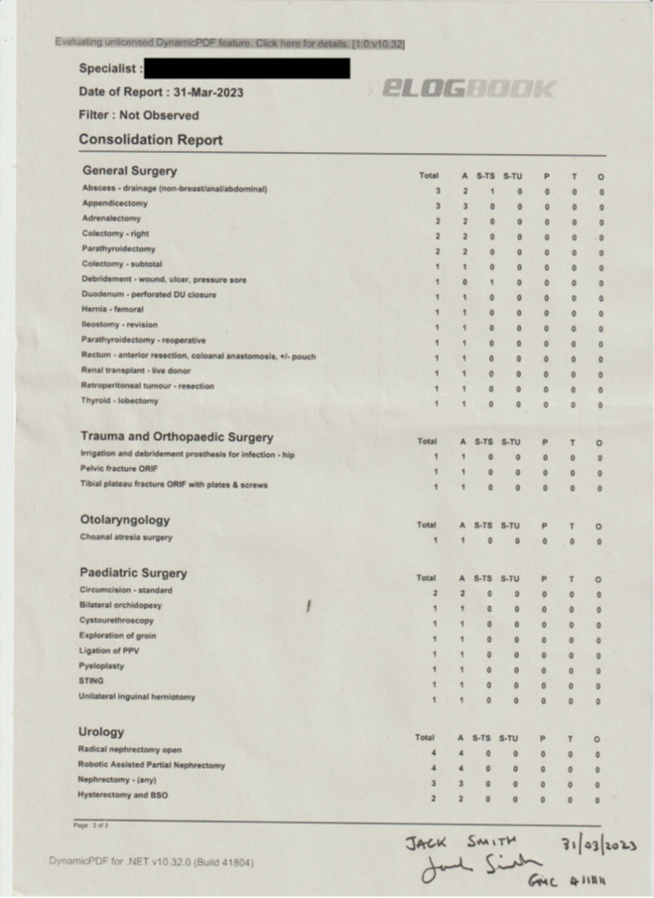

QIP / Audit example 1

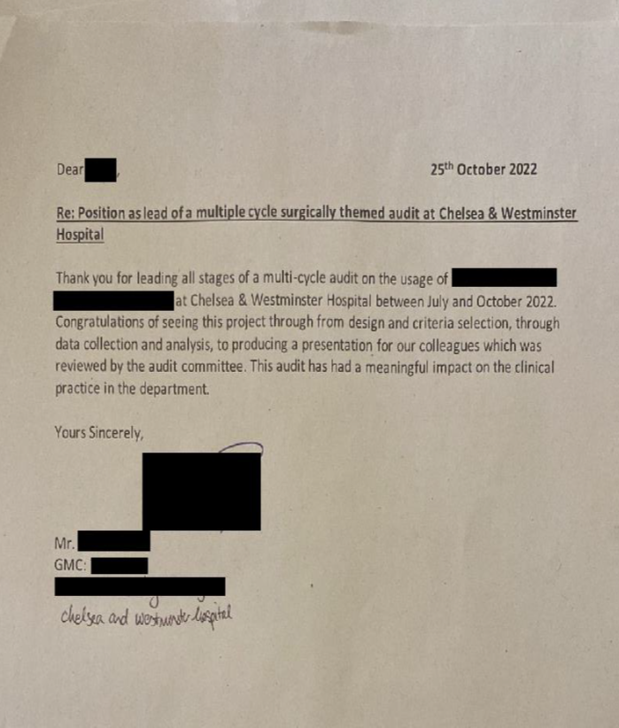

Presentation acceptance letter
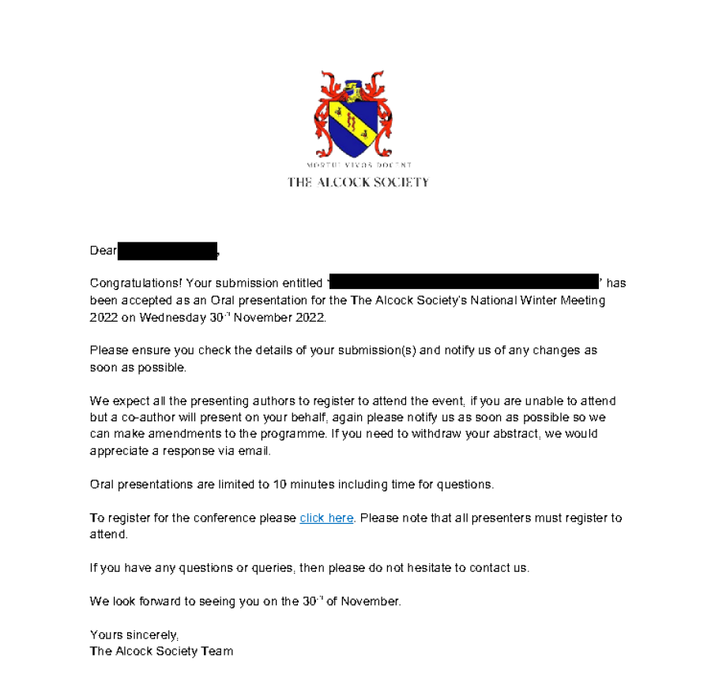

QIP / Audit example 2


Instructions for uploading to the Portal -
Introduction
All documents per domain should be uploaded as one continuous PDF file under the relevant domain on the Self-Assessment portal.
Files should be uploaded to the portal under each domain and saved with the following tag-
Evidence Title, oriel pin, surname, first name
Organisation of document
To help the panel with the organisation and ease of reading, your documents are standardised with the following:
Domain 1 Commitment to specialty
Domain 2 Quality improvement / Clinical audit
Domain 3 Presentations and Publications
Domain 4 Teaching Experience
We have outlined how much evidence will be reviewed by the panel to ensure that candidates are aware any evidence outside of the limit is not reviewed.
Please use the index page below as the front sheet for your evidence under each domain.

ELOGBOOK
How to create the consolidation sheet for elogbook:
- Log in to eLogbook
- Select the “Reports” tab under the heading “Operative Records”
- Select:
- Specialty: “Pan Specialty (including all specialties)”
- Type: “Standard (ordered by frequency of procedure, list all operations)”
- Format: “Normal”
- Filter: no filter is required.
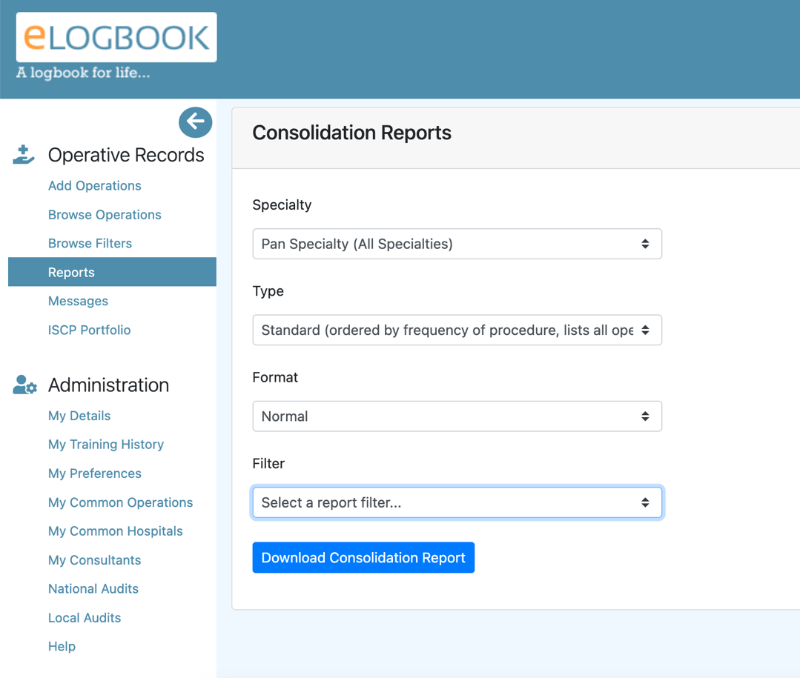
- Click on “Download consolidation report”

